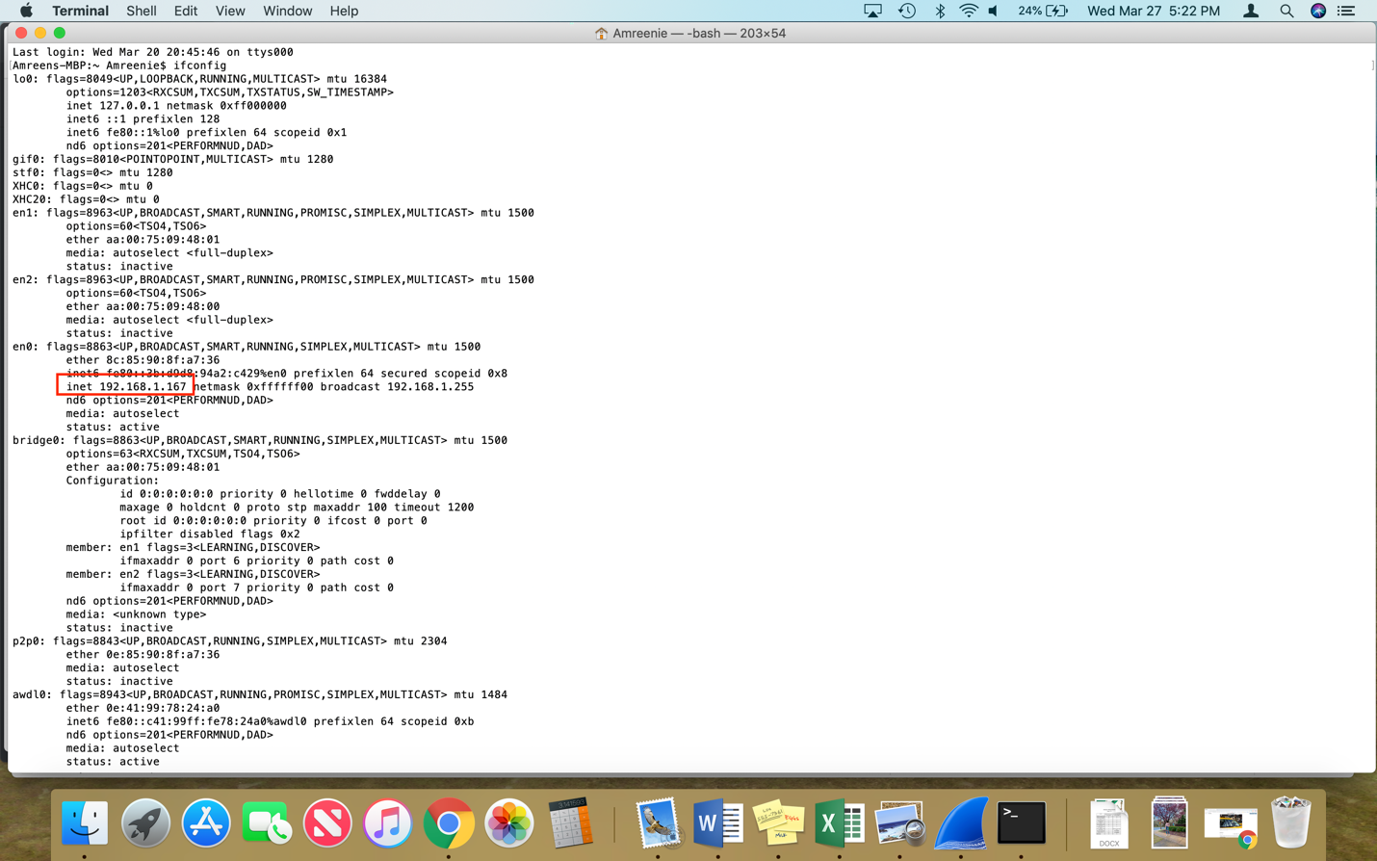

1. What is the MAC address from your computer?

It is 8c:85:90:8f:a7:36.

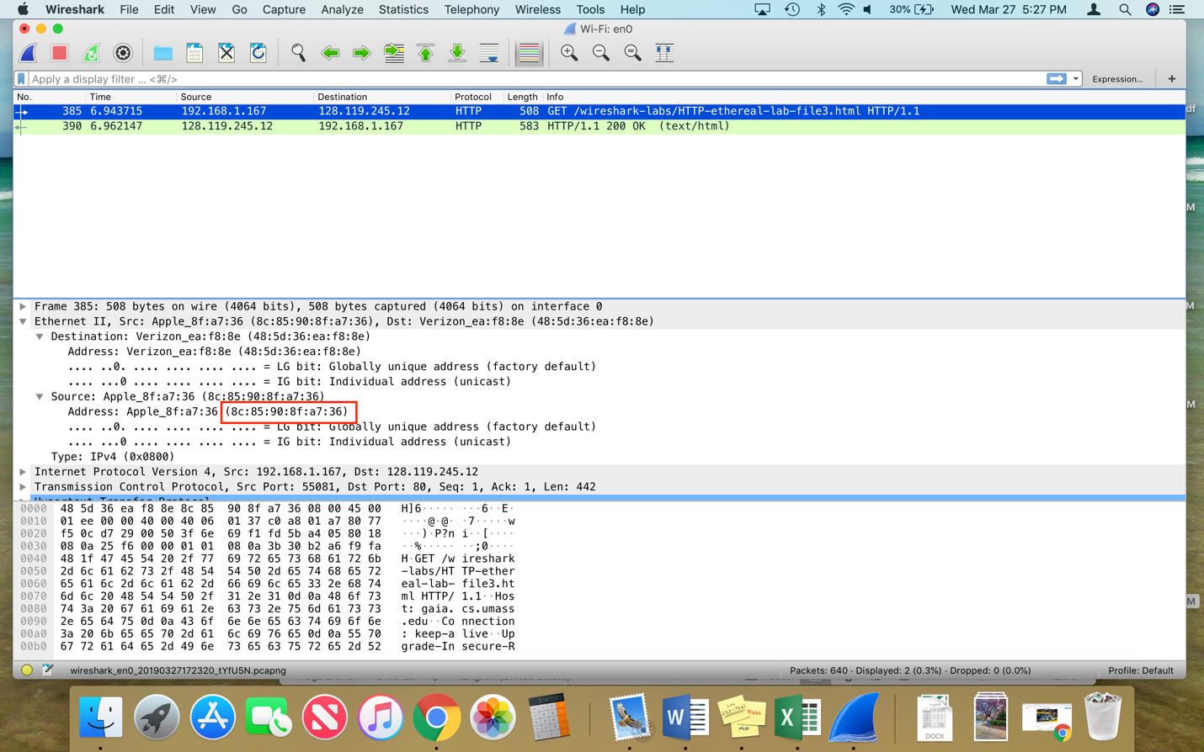

1. What is the destination MAC address?

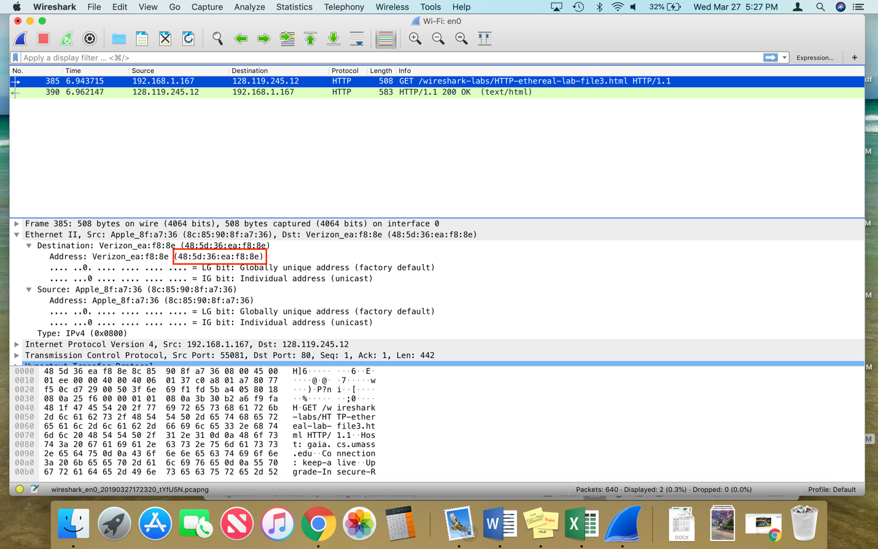The source MAC address is 48:5d:36:ea:f8:8e.

1. What device has the MAC address shown in the destination?

The router is the MAC address shown at the destination.

1. Explain the relationship between the destination MAC address and the destination IP address.

MAC Addresses are used on different local ethernet networks while IP addresses are used on networks. Another thing to note is that the MAC address delivers data to a device on a network whereas the IP Address is what carries that data to a device. The two are needed so that data can be sent over a network. The two basically identify a device on a network; the MAC address is the physical address used by machines. The IP address is the address for connecting to the internet; both together are needed to access the internet.

1. Using the terminal (cmd in Windows, Terminal in mac), run a command to display your full ARP list table. (Find out what the command is, and print a full screen shot of your result.)

